In this simulation I loaded the hello example and saw how the process worked.

In the beginning when I clicked on the run command, the program fetches the data through the bus.

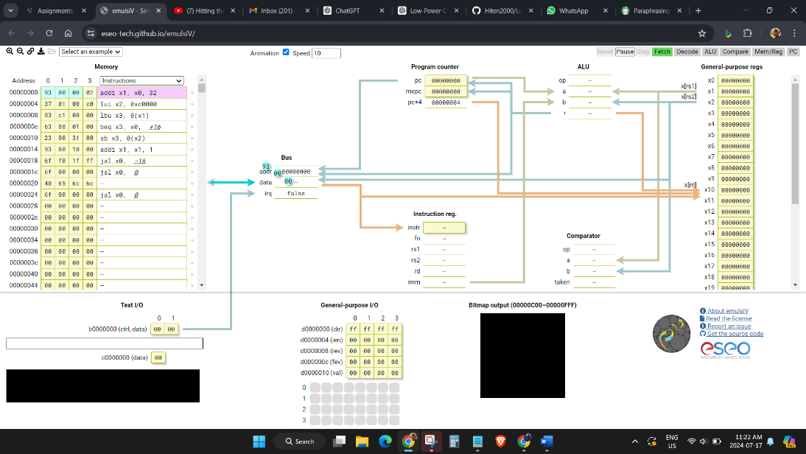

Then the data is sent to be decoded at the instruction reg.

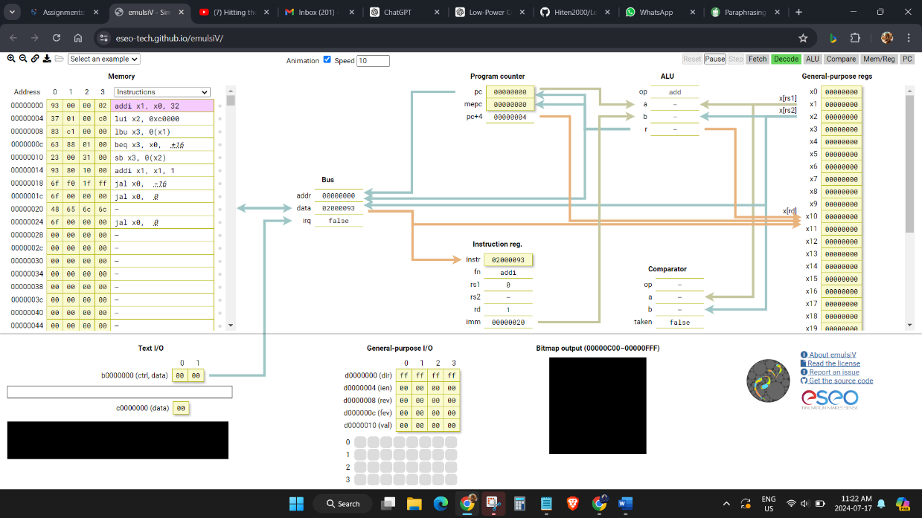

After the decoding is done, the ALU processes it and compares it.

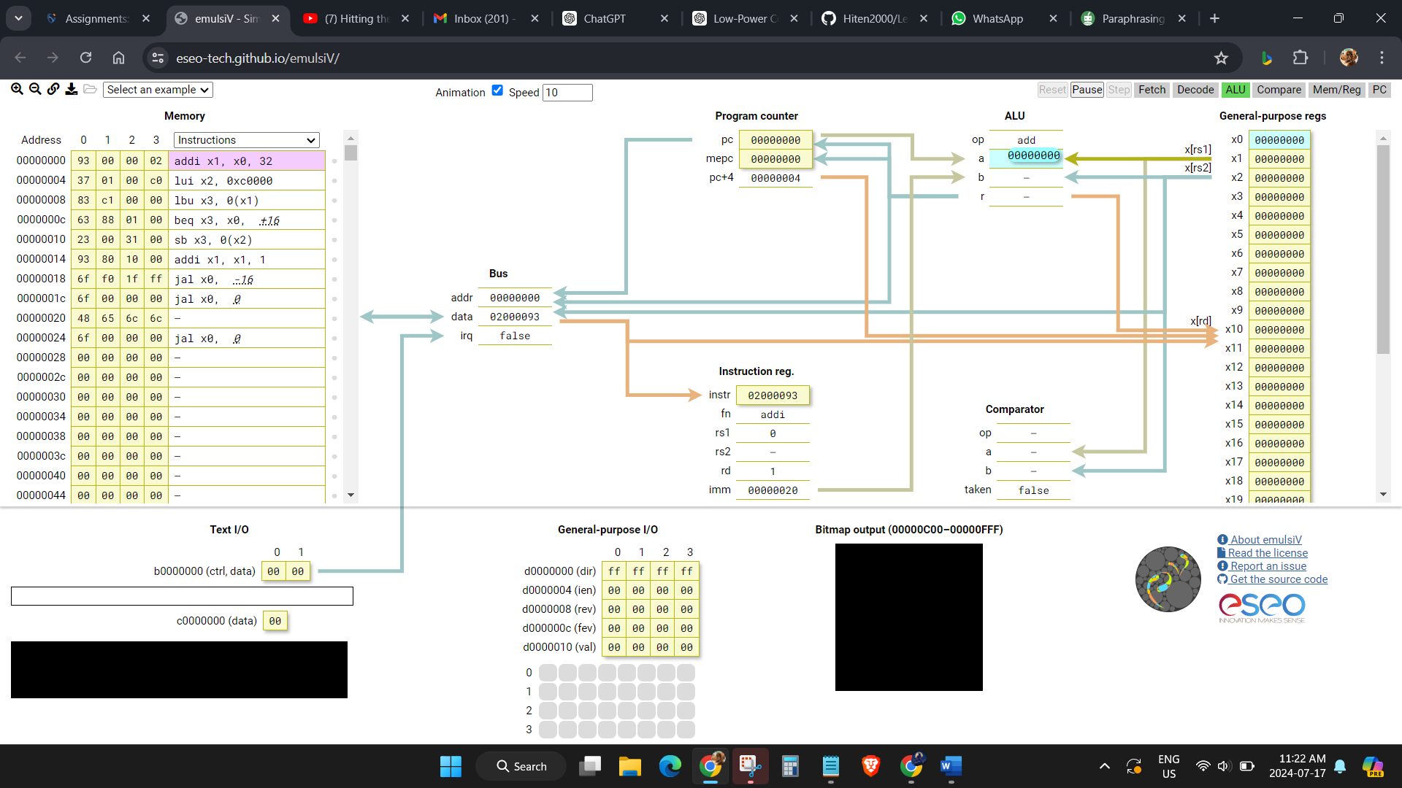

The last part is when it goes through the memory and registers and then finally to the PC.

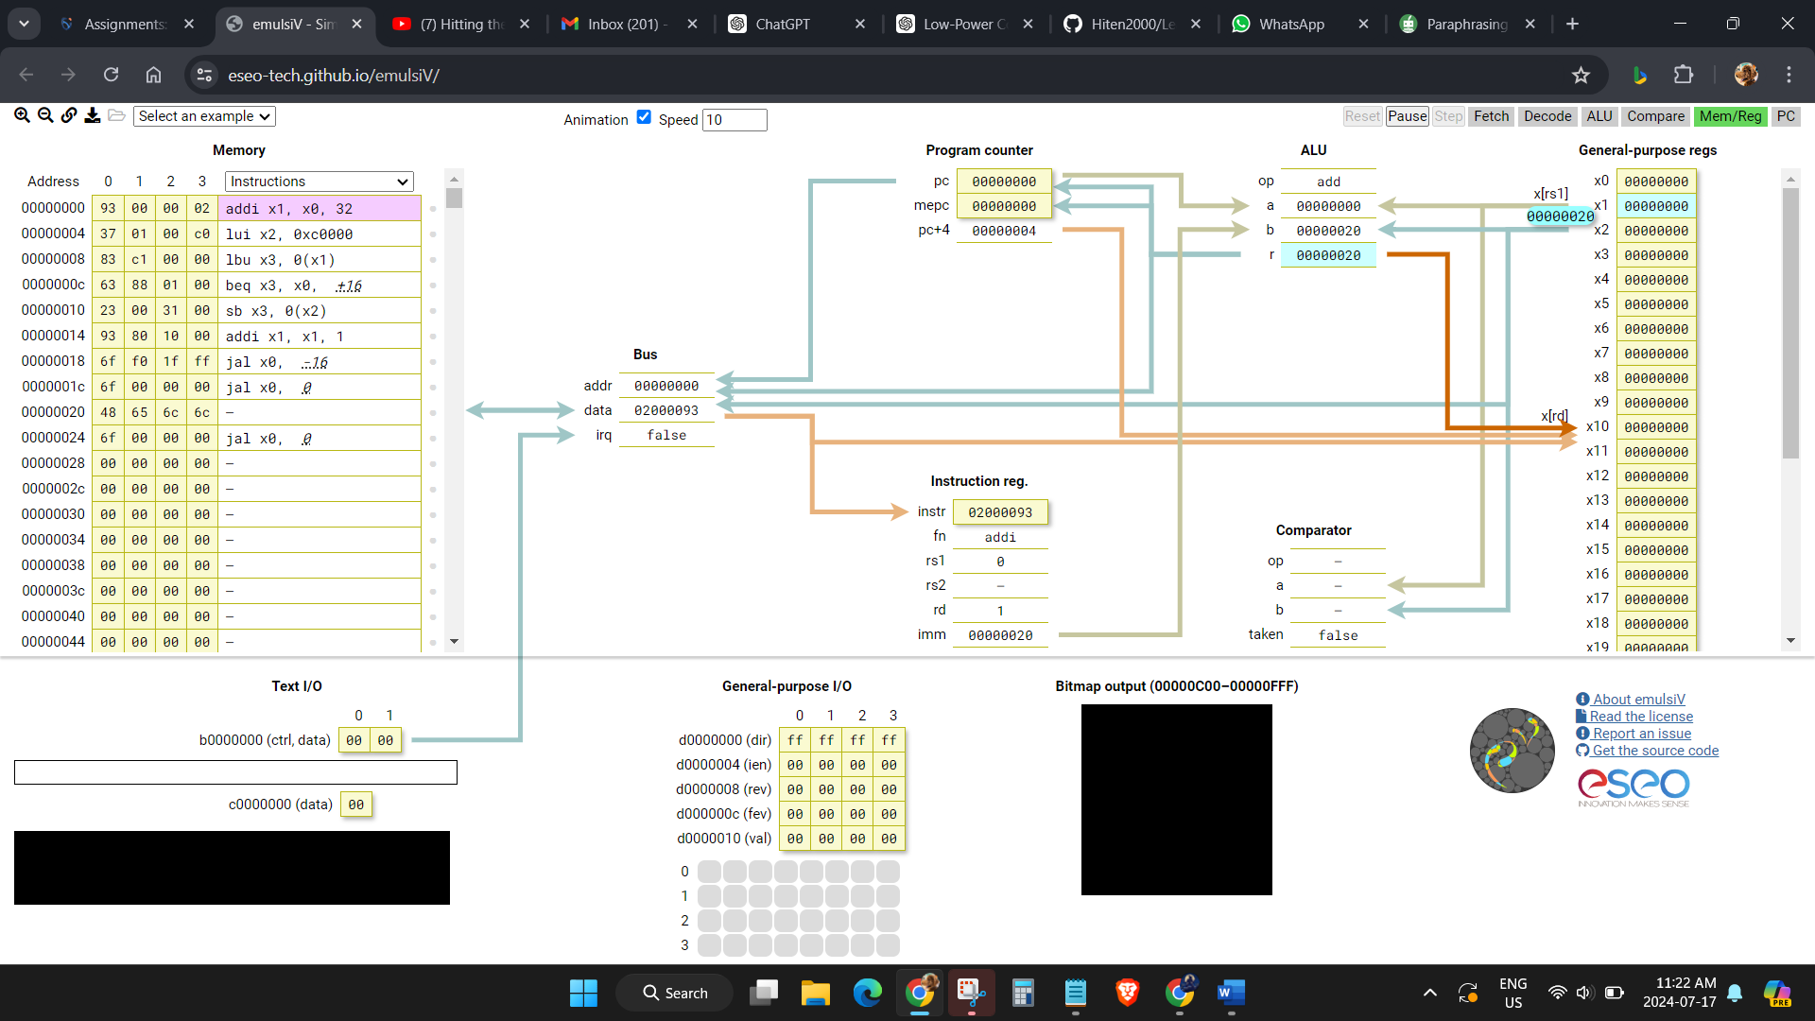

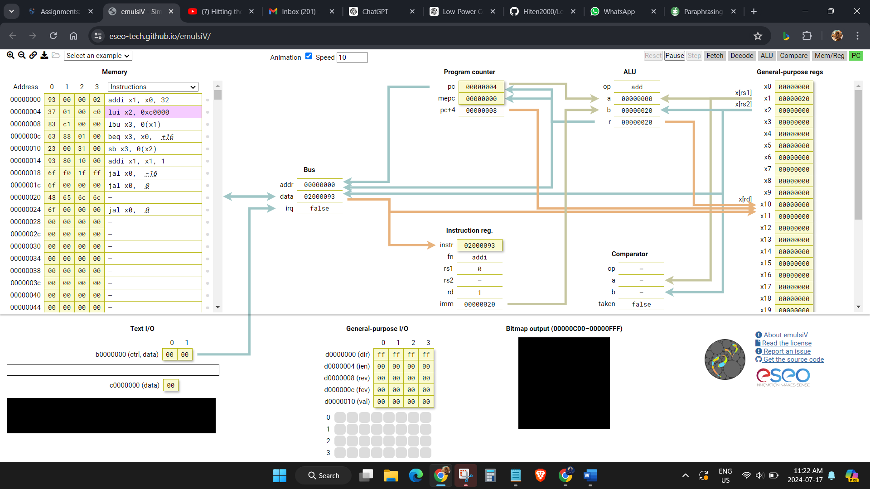

The crazy part is that everything happens in a fraction of second and our PC does that countless times in any given minute.